Add in classes and how they interact:

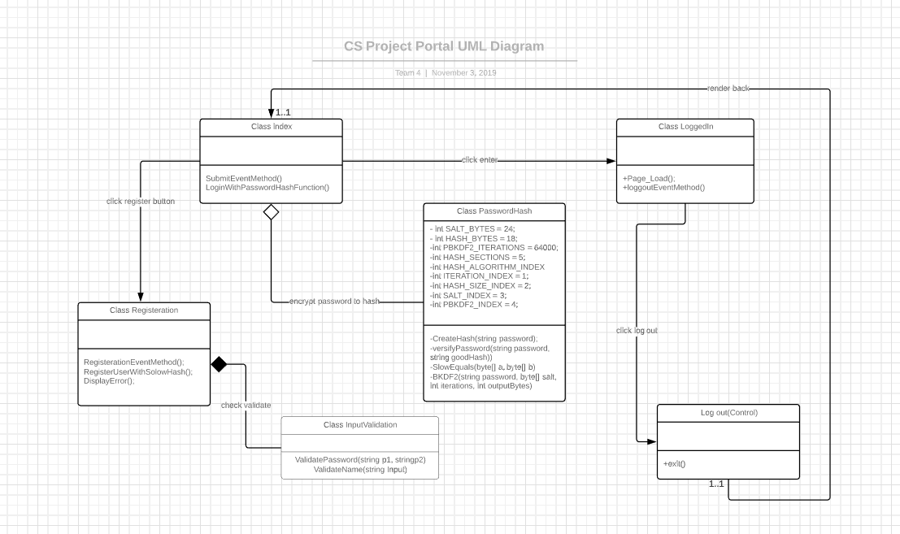

**Class Hierarchy auto generate By Doxygen.**

